Mark Ciganovic

Descriptive Statistics

*1. First, create a histogram depicting the relative frequencies of the card values for a single draw. Report the mean, median, and standard deviation of the value distribution. (You should have performed this step in the Distribution of Card Values section.*

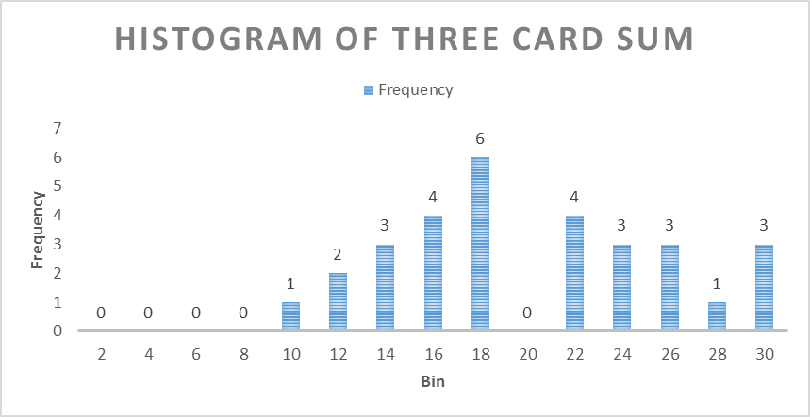

MEAN = 6.54

MEDIAN = 7

STANDARD DEVIATION = 3.15

*2. Take a look at the distribution of the three-card sums from the samples that you obtained, either from Generate Data, or from your own collection. Report descriptive statistics for the samples you have drawn. Include at least two measures of central tendency and two measures of variability*.

MEAN = 19.53

MEDIAN = 18.00

STANDARD DEVIATION = 5.69

IQR = 8.75

*3. Create a histogram of the sampled three-card sums. Compare its shape to that of the original distribution. How are they different, and can you explain why this is the case?*



The difference is that the histogram of the three card sum follows more of a normal distribution, whereas the histogram of the one card draw follows a uniform distribution, with the exception of a peak at the value 10. This makes sense since the if you choose one card, then there is an equal chance of getting any card, and since face cards all have the value of 10, the histogram should be uniform with the exception of a peak at 10. The three card draw should follow a more normal distribution, since the higher the sample size, the more the histogram will follow a normal distribution. I did notice that there is somewhat of a negative skew to the three card histogram, and I attribute this to the fact that the value of 10 is 4 times more likely to come up compared to any other number.

*4. Make some estimates about values you would get on future draws. Within what range will you expect approximately 90% of your draw values to fall? What is the approximate probability that you will get a draw value of at least 20? Make sure you justify how you obtained your values.*

I would expect 90 percent of the draws to fall in between 10 and 29. I justify this decision by going to the z score table, and finding that 1.64 standard deviations plus and minus the mean is where 90 percent of draws should lie. I then take the standard deviation, which is 5.69, and I multiply it by 1.64, and then both add and subtract that number from the mean, and it gives me 10.20 and 28.72, and then round those numbers, and I get 10 and 29. The probability that I get at least 20 is .504, the way I justify that is by taking 19.5 as the minimum score needed, since I am rounding numbers. The mean is 19.53, so the mean is only .03 above the number needed. I take .03 and divide it by the standard deviation 5.69, and I get .01. I go to the z score table, and I get the value of .50399, which I round to .504.